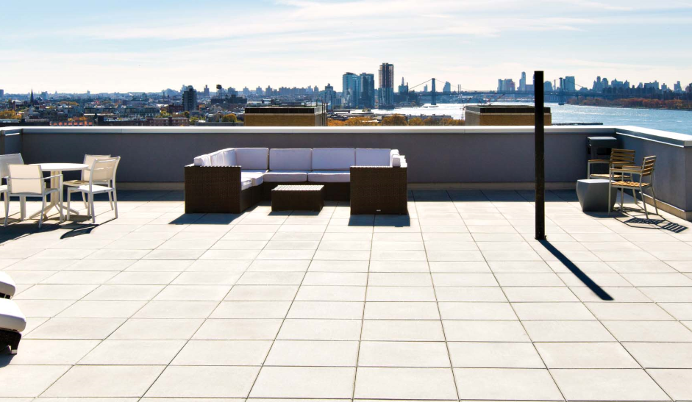

**COOL-ROOF**

Our special cool roof tiles selection includes glazed porcelains from the italian manufacturer, Adeline.  arabescato and beige

marbles now available in Polished finishes.

Available in a wide variety of sizes, shapes, and mosaics.

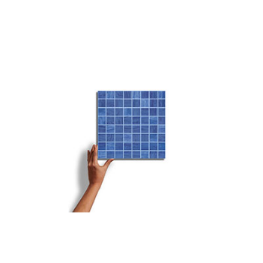

**Chante blue**

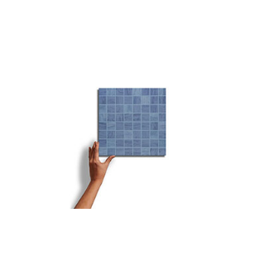

***Chante torquoise***

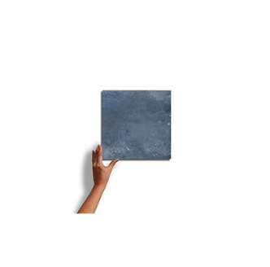

**Ploss blue**

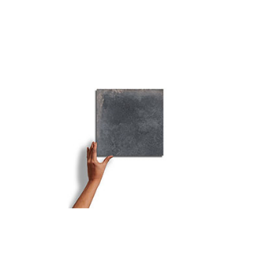

**Grey almot**

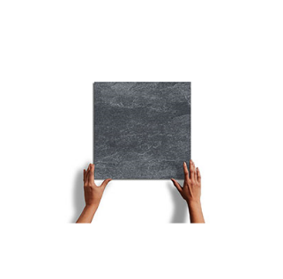

**Cherise**

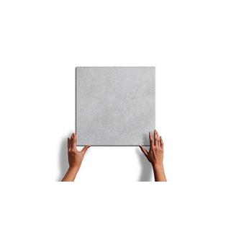

**Sliviasa**

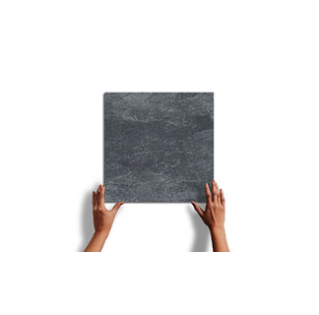

**Arebeque**

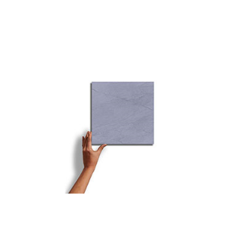

**Helvetico**

**COOL-ROOF TILES** TECHNICAL INFORMATION

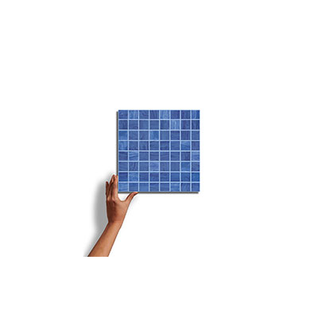

**CHANTE BLUE**

A beautifully glazed porcelain collection from germany creates a blend of marbles with a subtle antiqued look. Blending the veining of white Italian marbles (Carrara, Statuario, Gioia, and Venatino) in both White and Black creates a variety of sizes and patterns to create custom designs.

SPECIFICATIONS

**Country of Origin**

Italy

**Wear Rating**

Class 5 Suitable for all Residential and Commercial Application. Class 5 tiles are suitable for all applications including those with heavy traffic and constant use. (i.e., Shopping Malls, Hospitals), Class 3 Residential Applications. Suitable for all residential applications.

**Shade Variation**

V3 - Moderate Variation While the colors present on a single piece of tile will be indicative of the colors to be expected on the other tiles, the amount of colors on each piece will vary significantly.

**Frost Proof**

Yes

**Finish**

Glazed

**Material**

Porcelain

**Bullnose**

Yes

**COOL-ROOF TILES** TECHNICAL INFORMATION

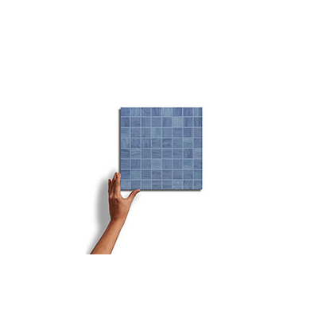

**CHANTE TORQUOISE**

A beautifully glazed porcelain collection from Italy creates a blend of marbles with a subtle antiqued look. Blending the veining of white Italian marbles (Carrara, Statuario, Gioia, and Venatino) in both White and Black creates a variety of sizes and patterns to create custom designs.

SPECIFICATIONS

**Country of Origin**

Pakistan

**Wear Rating**

Class 5 Suitable for all Residential and Commercial Application. Class 5 tiles are suitable for all applications including those with heavy traffic and constant use. (i.e., Shopping Malls, Hospitals), Class 3 Residential Applications. Suitable for all residential applications.

**Shade Variation**

V3 - Moderate Variation While the colors present on a single piece of tile will be indicative of the colors to be expected on the other tiles, the amount of colors on each piece will vary significantly.

**Frost Proof**

Yes

**Finish**

Glazed

**Material**

Porcelain

**Bullnose**

Yes

**COOL-ROOF TILES** TECHNICAL INFORMATION

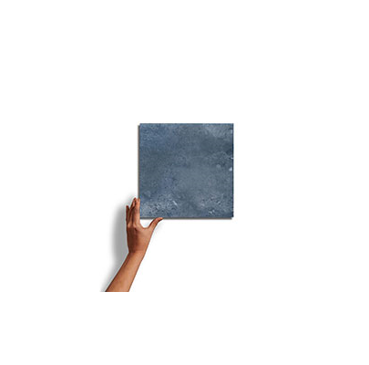

**PLOSS BLUE**

A beautifully glazed porcelain collection from Italy creates a blend of marbles with a subtle antiqued look. Blending the veining of white Italian marbles (Carrara, Statuario, Gioia, and Venatino) in both White and Black creates a variety of sizes and patterns to create custom designs.

SPECIFICATIONS

**Country of Origin**

Italy

**Wear Rating**

Class 5 Suitable for all Residential and Commercial Application. Class 5 tiles are suitable for all applications including those with heavy traffic and constant use. (i.e., Shopping Malls, Hospitals), Class 3 Residential Applications. Suitable for all residential applications.

**Shade Variation**

V3 - Moderate Variation While the colors present on a single piece of tile will be indicative of the colors to be expected on the other tiles, the amount of colors on each piece will vary significantly.

**Frost Proof**

Yes

**Finish**

Glazed

**Material**

Porcelain

**Bullnose**

Yes

**COOL-ROOF TILES** TECHNICAL INFORMATION

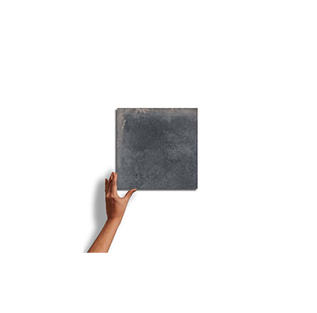

**GREY ALMOT**

A beautifully glazed porcelain collection from Germany creates a blend of marbles with a subtle antiqued look. Blending the veining of white Italian marbles (Carrara, Statuario, Gioia, and Venatino) in both White and Black creates a variety of sizes and patterns to create custom designs.

SPECIFICATIONS

**Country of Origin**

Germany

**Wear Rating**

Class 5 Suitable for all Residential and Commercial Application. Class 5 tiles are suitable for all applications including those with heavy traffic and constant use. (i.e., Shopping Malls, Hospitals), Class 3 Residential Applications. Suitable for all residential applications.

**Shade Variation**

V3 - Moderate Variation While the colors present on a single piece of tile will be indicative of the colors to be expected on the other tiles, the amount of colors on each piece will vary significantly.

**Frost Proof**

No

**Finish**

Glazed

**Material**

Porcelain

**Bullnose**

Yes

**COOL-ROOF TILES** TECHNICAL INFORMATION

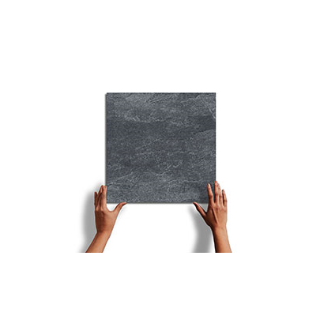

**CHERISE**

A beautifully glazed porcelain collection from Italy creates a blend of marbles with a subtle antiqued look. Blending the veining of white Italian marbles (Carrara, Statuario, Gioia, and Venatino) in both White and Black creates a variety of sizes and patterns to create custom designs.

SPECIFICATIONS

**Country of Origin**

Portugal

**Wear Rating**

Class 5 Suitable for all Residential and Commercial Application. Class 5 tiles are suitable for all applications including those with heavy traffic and constant use. (i.e., Shopping Malls, Hospitals), Class 3 Residential Applications. Suitable for all residential applications.

**Shade Variation**

V3 - Moderate Variation While the colors present on a single piece of tile will be indicative of the colors to be expected on the other tiles, the amount of colors on each piece will vary significantly.

**Frost Proof**

No

**Finish**

Glazed

**Material**

Porcelain

**Bullnose**

No

**COOL-ROOF TILES** TECHNICAL INFORMATION

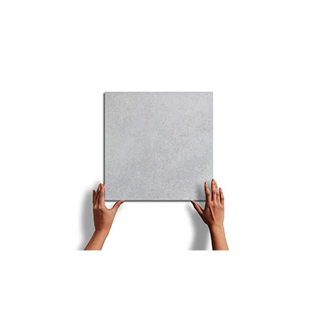

**SLIVIASA**

A beautifully glazed porcelain collection from Italy creates a blend of marbles with a subtle antiqued look. Blending the veining of white Italian marbles (Carrara, Statuario, Gioia, and Venatino) in both White and Black creates a variety of sizes and patterns to create custom designs.

SPECIFICATIONS

**Country of Origin**

Germany

**Wear Rating**

Class 5 Suitable for all Residential and Commercial Application. Class 5 tiles are suitable for all applications including those with heavy traffic and constant use. (i.e., Shopping Malls, Hospitals), Class 3 Residential Applications. Suitable for all residential applications.

**Shade Variation**

V3 - Moderate Variation While the colors present on a single piece of tile will be indicative of the colors to be expected on the other tiles, the amount of colors on each piece will vary significantly.

**Frost Proof**

Yes

**Finish**

Glazed

**Material**

Porcelain

**Bullnose**

Yes

**COOL-ROOF TILES** TECHNICAL INFORMATION

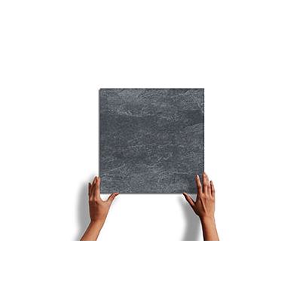

**AREBEQUE**

A beautifully glazed porcelain collection from Italy creates a blend of marbles with a subtle antiqued look. Blending the veining of white Italian marbles (Carrara, Statuario, Gioia, and Venatino) in both White and Black creates a variety of sizes and patterns to create custom designs.

SPECIFICATIONS

**Country of Origin**

India

**Wear Rating**

Class 5 Suitable for all Residential and Commercial Application. Class 5 tiles are suitable for all applications including those with heavy traffic and constant use. (i.e., Shopping Malls, Hospitals), Class 3 Residential Applications. Suitable for all residential applications.

**Shade Variation**

V3 - Moderate Variation While the colors present on a single piece of tile will be indicative of the colors to be expected on the other tiles, the amount of colors on each piece will vary significantly.

**Frost Proof**

Yes

**Finish**

Glazed

**Material**

Porcelain

**Bullnose**

Yes

**COOL-ROOF TILES** TECHNICAL INFORMATION

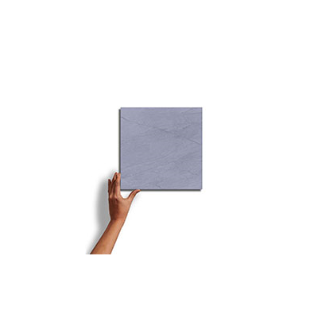

**HELVETICO**

A beautifully glazed porcelain collection from spain creates a blend of marbles with a subtle antiqued look. Blending the veining of white Italian marbles (Carrara, Statuario, Gioia, and Venatino) in both White and Black creates a variety of sizes and patterns to create custom designs.

SPECIFICATIONS

**Country of Origin**

Spain

**Wear Rating**

Class 5 Suitable for all Residential and Commercial Application. Class 5 tiles are suitable for all applications including those with heavy traffic and constant use. (i.e., Shopping Malls, Hospitals), Class 3 Residential Applications. Suitable for all residential applications.

**Shade Variation**

V3 - Moderate Variation While the colors present on a single piece of tile will be indicative of the colors to be expected on the other tiles, the amount of colors on each piece will vary significantly.

**Frost Proof**

Yes

**Finish**

Glazed

**Material**

Porcelain

**Bullnose**

Yes

NOTES

Always inspect materials prior to installation.

Always mix 2-3 cartons at a time while installing to insure the best blend.

Per ANSI standard A108.02,4.3.82, tiles longer than 18” should not be staggered more than 1/3

the length of the tile.

All product images are representation only. Variation in color and shading is to be expected.

Final selection should be made from actual tile samples.